User Manual
Reporting Obligations Database
Prepared by
Risto Alt
January 2007
Version 1.1
User manual
Version management
No | Date | Changes | Author
1.0 | 2006.04.01 | Initial version | Risto Alt
1.1 | 2007.11.20 | Conversion to OpenDocument | Søren Roug

Project manager: Søren Roug
Contents
1. Functionality 4
1.1. Index page 4
1.2. Log in as Administrator 5
1.3. Legislative instruments hierarchy 7
1.4. List of Obligations 8
1.5. Legislative instrument details 12
1.6. Reporting obligation details 16
1.7. Undo/Redo 22
1.8. Deadlines/Deliveries 25
2. RSS / RDF 32
3. XML-RPC Methods 32
4. Editing other information in ROD 36

Functionality
The ROD system has thin-client architecture, i.e. all data and most of the functionality resides on server and the client application is an ordinary Web-browser. A data communication between server and client takes place over standard HTTP protocol.
This kind of architecture of the ROD system assures its smooth integration into Internet community and especially into EIONET network. Also it does not require any additional software for the client except standard Web-browser (like Netscape Navigator or Internet Explorer), and the system is accessible (if not any special access constraints are not established) from any Internet-connected computer.
The ROD system provides two-level functionality: browsing and searching of legislative instrument/obligation data for all users, and data editing functionality for ROD administrators. Data browsing and searching functionality is available for every user having access to the Internet. To be able to edit ROD content, a user has to log into ROD as administrator and, given she has the required access rights, will have an ability to change data. To log into the system, user has to go through a special URL – the aim was to hide the possibility of data administration from greater public.
The functionality (both read-only and editing pages) is described in the following sections, where the screenshots of system pages are presented and an explanation of the page functionality is given.

Index page
Index page (Figure 1) is the first page that is displayed when a user points her Web-browser to the ROD address at http://rod.eionet.eu.int. This page is also displayed when the user clicks “ROD” link in the menu panel of any of the ROD pages.
The content of the database can be browsed by clicking the links of categorized legislative instruments and reporting obligations. It is also possible to browse ROs by using the search to specify the documents that are going to be displayed. Help is also available for all search and administration interfaces by clicking the help (‘?’) buttons. At the bottom of the screen, various feedback and statistics links are displayed.
Each page in ROD has a Navigation Bar on the left side of the screen where user can navigate to different reporting obligations and deadlines (data sets reported by countries for each of the activities). When users login to the system, they get access to edit pages. Links to maintenance pages and login page are not shown in the Navigation Bar.
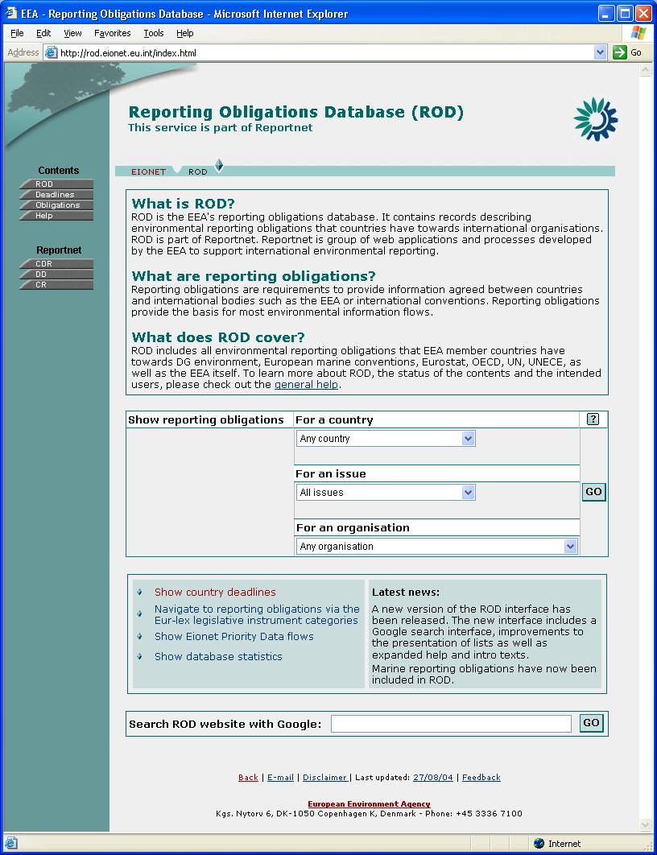Figure 1:Index page

To get access to data administration pages http://rod.eionet.eu.int/login.html has to be used instead of the usual URL.

Log in as Administrator
By entering the login page URL (see above) the screen similar to Figure 2 is shown.
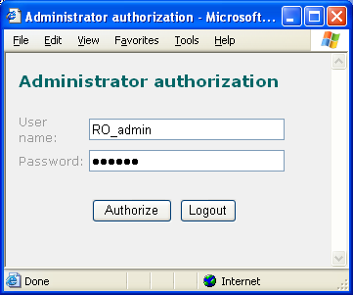Figure 2:Login dialog
Here the user has types in the ROD administrator’s user name and password and clicks the ’Authorize’ button to log in. The same window can also be used for logging out by clicking the ‘Logout’ button (no user credentials need to be entered in that case). Alternatively, ‘Logout’ button on the left-hand pane can be clicked.
After clicking the ’Authorize’ button, ROD checks the given credentials and if they are correct, user is logged in as an administrator. Then the user is redirected to the Index page and the ROD/system pages will contain icons for adding, modifying and/or deleting data items, depending on the access rights given to this particular user. Note that the administrative interfaces described in this document have most of the options enabled, something that might not be likely with real users.
Administrator information is stored using HTTP session mechanism, what uses ‘session cookies’ to exchange information between client and server. Therefore for the server to be able to maintain the administrator session, a browser should accept session cookies (check that in Web-browser settings, session cookies are enabled). Also, the administrator session has a timeout, meaning that after certain length of inactivity period (default is 10 hours), the session is declared to be expired and for administrator rights a user has to log in again.
For the ROD system editor pages JavaScript has to be enabled in the browser, because on those pages JavaScript is used to check validity of the input data, etc.
When the entered user name and password were not correct, a page with relevant information is displayed (Figure 3). By clicking the ‘Back’ link on that page, a login dialog will be displayed again and the user can re-enter the administrator credentials.
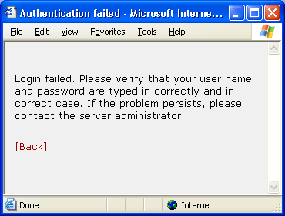Figure 3:Login failed dialog

Legislative instruments hierarchy
Legislative instruments, the highest level in the legislative instrument – reporting obligation relationship, can be accessed by clicking on ‘Navigate to reporting obligations via the Eur-lex legislative instrument categories’ in the box below the search form. On legislative instruments page, an instruments hierarchy for the given section is displayed (by clicking the respective button, help is also available, as is – for authorized users – the list of deleted instruments and the ability to add new instrument). For example in Figure 4, a hierarchy for section ‘15.10.20 Pollution and nuisances’ is presented. Under the top-level hierarchy item its sub-sections (15.10.20.10 – 15.10.20.50) are displayed and at the bottom of the page are the instruments belonging to section ‘15.10.20 Pollution and nuisances’.
By clicking on a sub-section link, a legislative instruments hierarchy for that sub-section is displayed (i.e. on this new page the clicked section will be a top level section). Clicking on the legislative instrument link, a page with this legislative instrument data is displayed (see Legislative instrument page section).
When clicking on the top-level section link (e.g. on ‘Pollution and nuisances’ in Figure 5), a legislation hierarchy page starting with its parent section is displayed (in our sample case the hierarchy would start from ’15.10 Environment’).
On the top of the page is a horizontal menu bar, indicating a context of the current page in the ROD application. Most of the ROD application pages contain that context bar.
For legislation hierarchy page it contains items ‘ROD’ and ‘Legislative Instruments’, what will respectively open index page or top-level legislation hierarchy page.
The left menu panel contains items ‘Obligations’– opens the obligations (see List of Obligations section), and ‘Deadlines’ – opens the Country Services part of ROD (see Deadlines/Deliveries section). General help and ROD index page can also be accessed from there. The menu panel will be displayed on all pages in ROD.
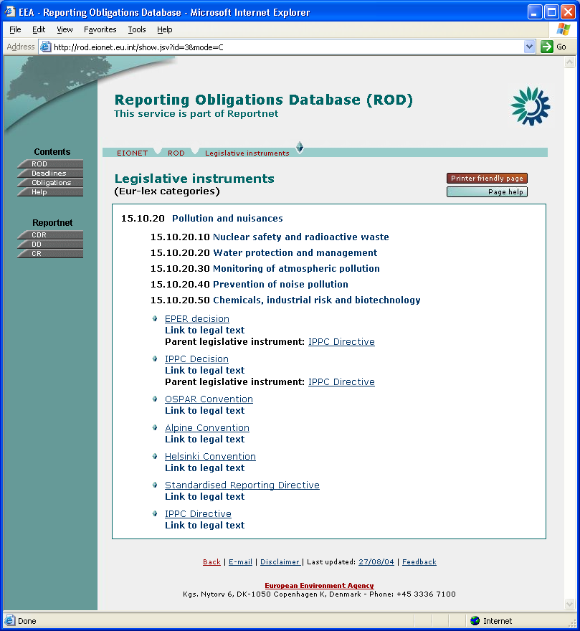Figure 4:Legislative instruments hierarchy

List of Obligations
This page (Figure 5) contains a list of reporting obligations (along with the legislative instruments they belong to) that can be picked for viewing/editing. Clicking on ‘Obligations’ link on the left-hand pane will display a list of all obligations. Search on the main page or this page (explained below) can be used to find only desired obligations. New obligations can also be added (assuming the necessary access rights) from this page by clicking the ‘New obligation’ button (not shown).
In addition to above, the detailed page of legislation (see Legislative Instrument Details section) link to this page showing the obligations related this certain legislative instrument.
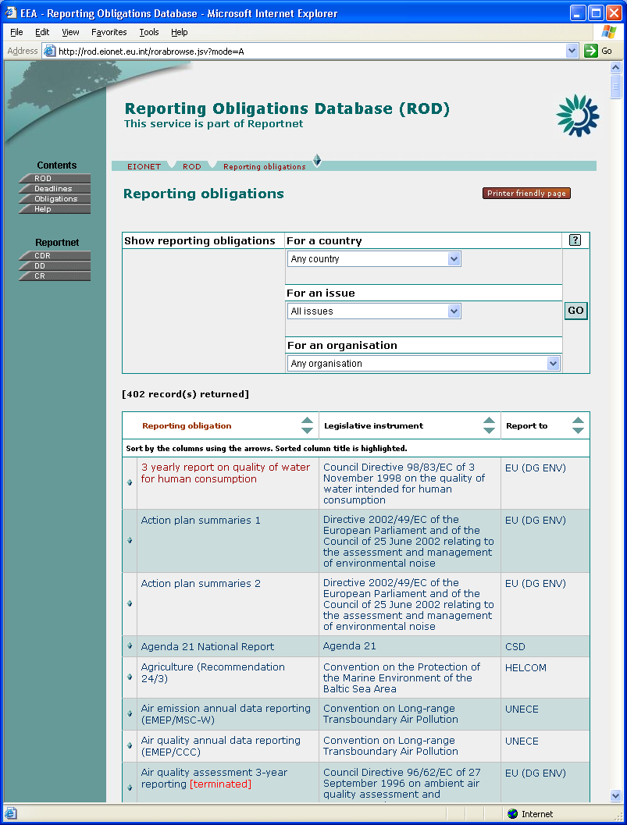Figure 5:List of all obligations
This page also displays a search tool similar to the one on the index page (Figure 6). This simple query form allows you to specify which obligations will appear in the list. Possible filters for the search are:
- Environmental issues
- Spatial coverage attributes: countries
- ‘Report To’ organisation.
You can choose only one item from each list. All the items are combined into one query with logical AND operator. For example, by choosing Country = ‘Denmark’ and Environmental issues = ‘Air Quality’ you will get all obligations related to Denmark that concern the Air Quality issue.
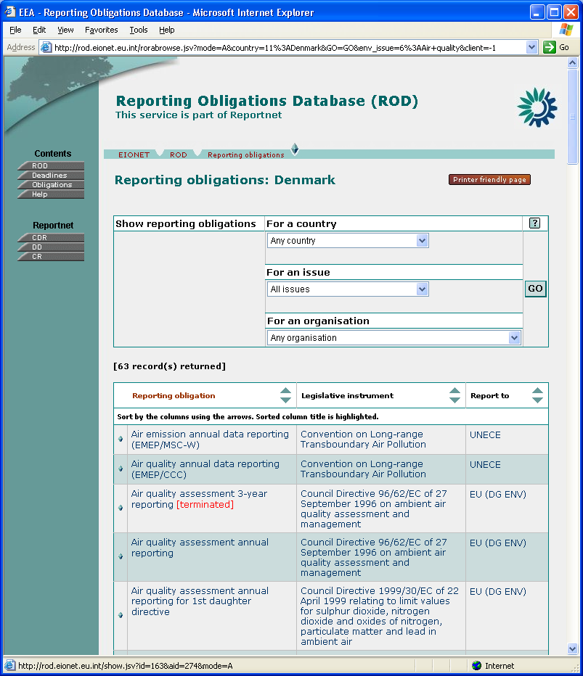Figure 6:Search tool for browsing obligations
Note also the help button on the search form. These work similarly on all the forms, so the principle is explained below only once.
For each form, there is an overview help button. On administrative interfaces, there are also context help buttons for each of the form fields. Clicking one of the buttons, popup window with help text is displayed (Figure 7 and Figure 8).
If the user has the required access rights, a checkmark-labelled button will also appear for editing help text. Clicking this button will open a popup window similar to the one displayed on Figure 9.
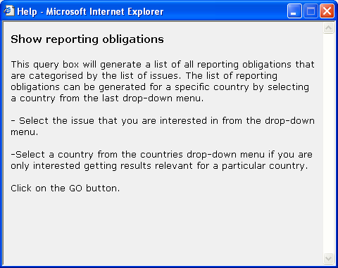Figure 7:Help window for search tool for browsing obligations

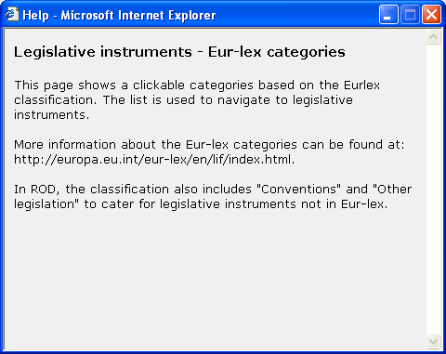Figure 8:Legislative instruments hierarchy help
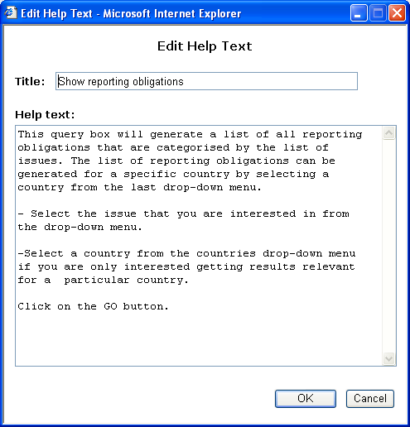Figure 9:Editing help text

Legislative instrument details
Legislative instrument’s information will be displayed when a user has selected this legislative instrument from the legislation hierarchy or the Reporting Obligation Details Page. From this screen, it is also possible to navigate to related (or parent) instruments and reporting obligations belonging to this instrument. It is also possible to switch to the edit mode of the document
In Figure 10, a page with legislative instrument ‘Commission Decision 95/337/EC of 25 July 1995 amending Decision 92/446/EEC of 27 July 1992 concerning questionnaires relating to directives in the water sector’ information is displayed. This screen is displayed in administrator mode, having additional icons for creating a new legislative instrument, editing the existing document, adding obligations to this legislative instrument, deleting the instrument, and viewing change history and field descriptions.
The items displayed on this page also depend on whether the legislative instrument is a convention (having its type set to convention) or other type. For convention, more information will be displayed, e.g. convention secretariat, EC accession etc.
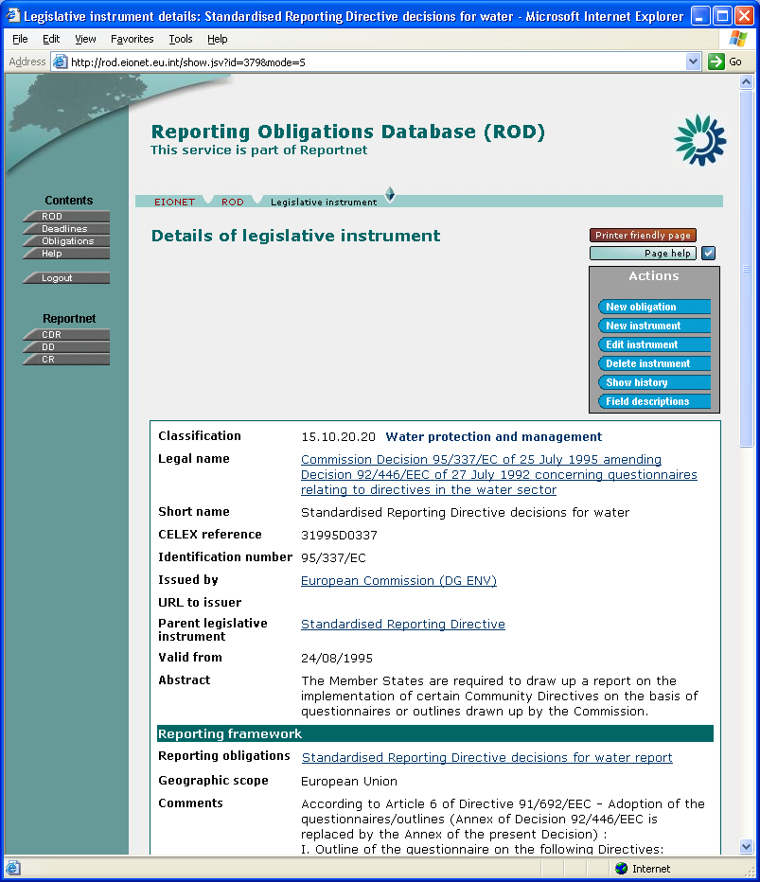Figure 10:Legislative instrument details
The blue action buttons on the right of the page are present only for administrators. Clicking on ‘New obligation’ will open a reporting obligation editor for adding a new reporting obligation record belonging to this legislative instrument. ‘New instrument’ will open a page where it is possible to add new legislative instruments. ‘Edit instrument’ opens a legislative instrument editor for this record, and ‘Delete instrument’ deletes the current legislative instrument. Finally, ‘Show history’ will display modification history in a popup window, and ‘Field descriptions’ will show explanations for all fields.
Under ‘Classification’ section, section names where to this legislative instrument belongs are displayed (reporting obligations belonging to this LI are also displayed here). Clicking on the section name will open a legislation hierarchy page for this section.
There can also be other legislative instruments linked to this legislative instrument. This relationship can be either:
- one legislation act relates to another; (parent)
- one legislation act is derived from other(s). (child)
These relationships are reflective, i.e. if legislative instrument A is related to B, then B is derived from A.
Clicking on the linked legislative instrument link, a page with the information of this legislative instrument will be opened.
A user having an administrator’s rights can delete the current record by clicking on ‘Delete instrument’. A confirmation message is displayed and after the user has pressed OK to confirm the delete, all related reporting obligation records with related obligation records will be deleted.
By clicking on the edit icon, a legislative instrument editor is opened (Figures 11 and 12).
Legislative instrument editor page consists of three sections: general attributes section (Figure 11) and, at the bottom part of the screen, convention attributes and record management sections (Figure 12).
To insert a new legislative instrument record, an existing record editor has to be opened and ‘New instrument’ button clicked (alternatively, the same button can be clicked from Legislative Instrument Hierarchy). A legislative instrument editor will appear. After typing in the information and pressing the ‘Save changes’ button, a new legislative instrument record with the entered information will be added to the database.
If the current legislative instrument amends some existing act, then this relationship can be specified by selecting a ‘Parent legislative instrument’ from the list.
For linking one or more items to one legislative instrument (‘Classification’), two select boxes are displayed. In the left-hand box are the items linked to this legislative instrument, and in the right-hand box are the rest of items. For example, a new classification(s) this legislative instrument belongs to can be added by selecting item(s) from the right-hand box and then clicking the ‘←‘ button. Similarly, to remove linked classification, select item(s) from the left-hand box and press the ‘→’ button. To select multiple items from the select box, a CTRL key has to be held down while the items are clicked with the mouse.
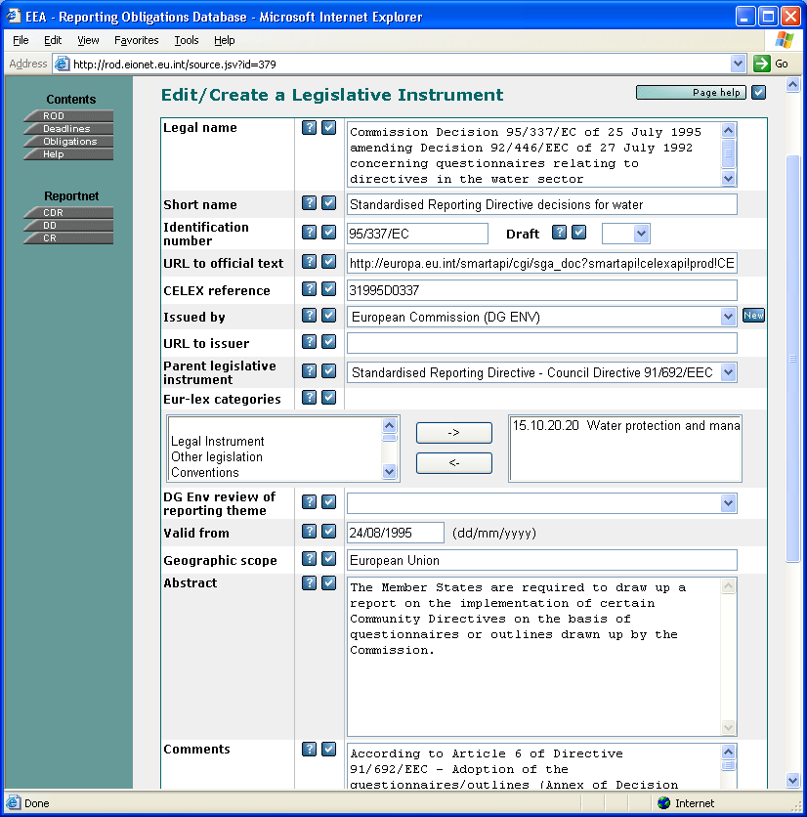Figure 11:Legislative instrument editor (a)
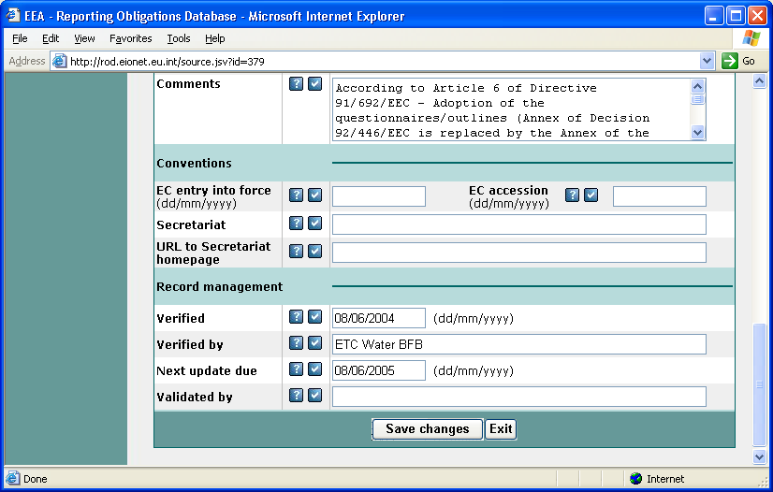Figure 12:Legislative instrument editor (b)
The convention attributes will be saved to the database, but for other types of legislative instrument they will not be displayed.
For entering data to the date fields, use the dd/mm/yyyy format.
The record management section is identical to LI and RO. In this section, verifier’s name or initials (‘Verified by’), verification date (‘Verified), next review date (‘Next update due’), and validator’s name or initials (‘Validated by’) can be specified.
The data will be saved to the database by clicking on the ‘Save changes’ button. At first a confirmation message is displayed and after pressing the ‘OK’ button, the data will be saved. A confirmation message to save updated data will be also displayed if user has changed something in the editor but navigates away from this page without saving the changes. This logic applies to all editor pages in the ROD system.

Reporting obligation details
Reporting obligation page (Figure 13) can be opened by clicking a link under ‘Reporting obligations’ on the legislative instrument page (Figure 10) or by clicking on an item in List of Reporting Obligations Page (Figure 5 and 6).
On that page, information about one reporting obligation with its linked activities is displayed. Clicking on the legislative instrument title will send the user back to the legislative instrument page. The same will happen if the user clicks on the ‘Legislation’ button in the context bar.
In the top-right corner are the icons to add, edit and delete the current reporting obligation record, and view change history. When deleting a reporting obligation record, at first confirmation is asked and when it is given, reporting obligation record with related links to submissions will be deleted and the user will be navigated to the parent legislative instrument page.
Clicking ‘New obligation’ will add a new obligation under the same legislative instrument as the obligation being viewed. To add a new obligation under different instrument, the user has to select ‘New obligation’ from the List of Obligations (Figure 5). This would first display legislative instrument hierarchy window, where the parent legislative instrument for the new obligation can be picked. Once this is done, reporting obligation editor (Figure 14) will appear, allowing details for the new obligation to be entered and saved to the database.
In the list of countries reporting according to this obligation, countries reporting voluntarily are marked with asterisk (*). Clicking on the small D button next to the list will provide history about join and leave dates of various countries for this obligation. Similarly, clicking the small D next to ‘Report to’ organization will display the details about this organization.
If parameters and/or indicators have been entered for this obligation, buttons for viewing them will also appear.
Note also the ‘Printer-friendly page’ button – this will open a printer-friendly version of the page. This button is also available in many other ROD pages.

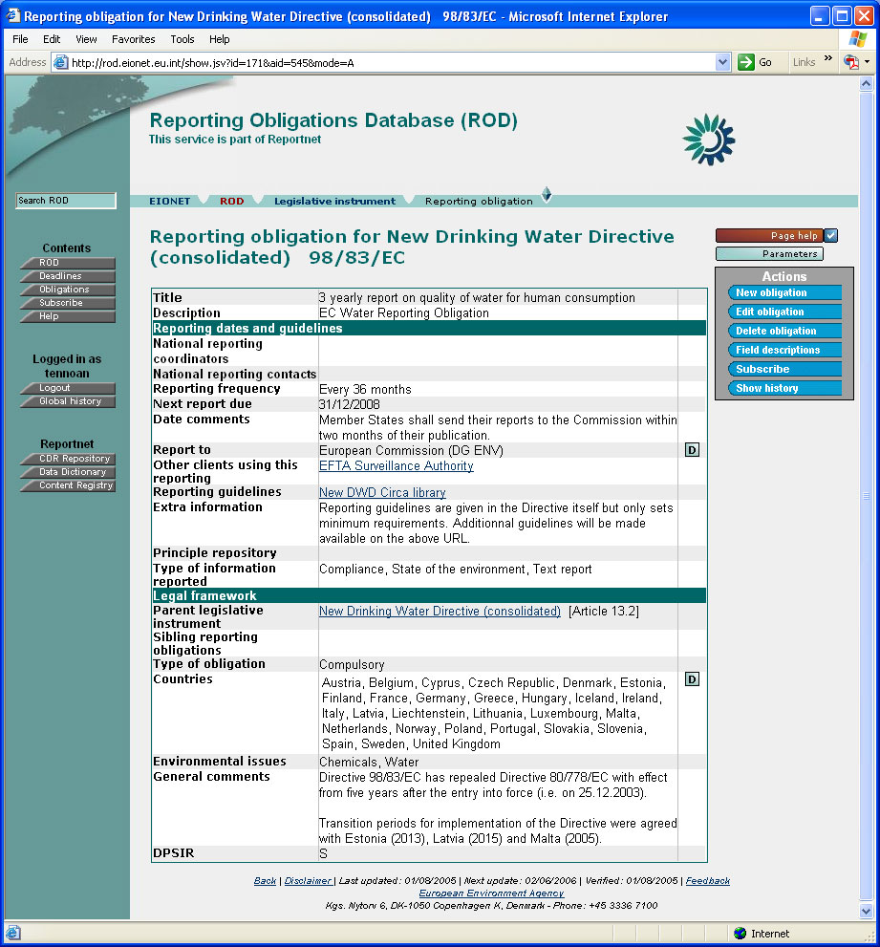Figure 13:Reporting obligation details
Reporting obligation editor (Figures 14, 15, and 16) allows updating information for the selected obligation.
‘Valid to’ is a date field that specifies how long the reporting obligation is going to be valid. When entering data, system will provide a default value of ‘31/12/9999’ after a value for ‘Baseline reporting date’ field has been entered or if nothing is entered into ‘Valid to’ field by the time the document is saved.
There are two ways to specify reporting deadline: text based (‘ASAP’, etc.) and date based. Exactly one must be used at the time. To use text based deadline, simply enter a value for ‘Reporting date (text format)’ field and leave ‘Reporting frequency’ field empty. The system will know you want to use text-based deadline.
To use date-based deadlines, enter a value for both ‘Baseline reporting date’ and ‘Reporting frequency in months’ (whole number) fields. From these, ‘Next due date’ is calculated according to the following rules (assuming ‘today’ is 05-12-2002 in our example):
- If the day of the starting date is < 28, a number of months specified in reporting frequency is added to the starting (baseline) date repeatedly, until ‘Next due date’ is in the future. For example, with 15-09-2002 start date and reporting frequency of 3 months, next reporting will be 15-12-2002.
- If the day of the starting date is >= 28, a number of months specified in reporting frequency is added to the starting date, until ‘Next due date’ is in the future¹, and the day set to the end of the month. For example, with 30-11-2002 start date and reporting frequency of 3 months, next reporting will be 28-02-2003.
- If reporting frequency in months is set to zero, the application assumes
non-repeating date and uses ‘Baseline reporting date’ date as the ‘Next due date’.
- The ‘Next due date’ will never be larger than ‘Valid to’ date (no need to report if obligation is no longer valid).
System will recalculate ‘Next due date’ fields for all obligations every day, so they are always up to date.
Editing country coverage (‘Countries reporting formally’ and ‘Countries reporting voluntarily’) and environmental issues is similar to ‘Classification’ editing in Legislative Instrument Edit page (Figure 11).
Value for ‘National Reporting Contacts’ and ‘National Reporting Coordinators’ needs to be CIRCA role (without the country-specific part which will be appended automatically unless ‘Do not append country suffix’ check box is selected), for example eionet-nrc-wtr. Alternatively, it can simply be name and URL.
Environmental issues can be managed by moving items between ‘linked’ and ‘available’ lists (see Legislative instrument page chapter for more information).
Record management (not shown) is the same as described in the legislative instrument section.
Clicking ‘Add a new indicator’ will, unsurprisingly, add a new indicator. A window will pop up where indicator details (title, number, URL, and owner) can be entered.

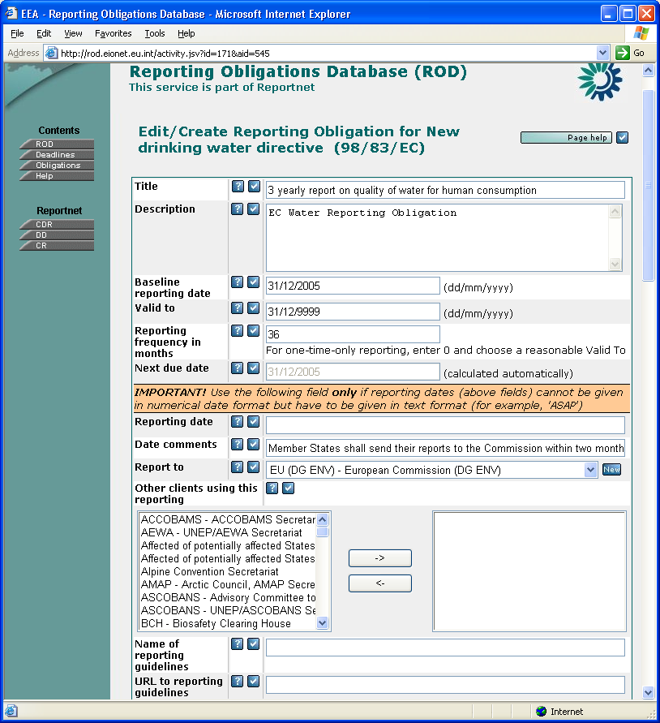Figure 14:Obligation editor (a)
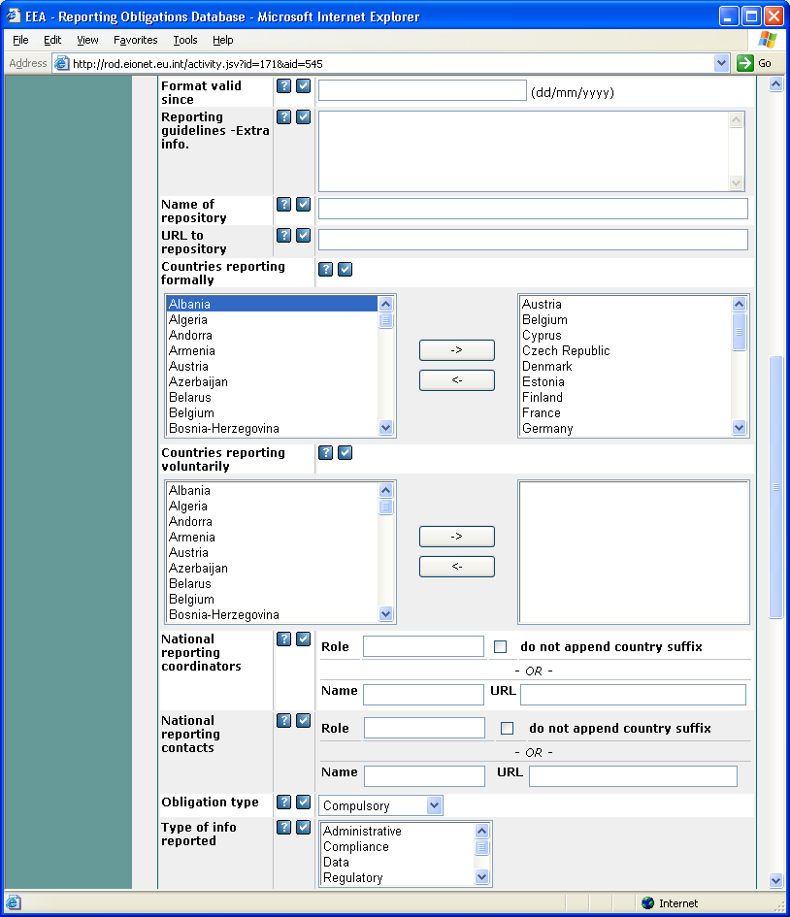Figure 15:Obligation editor (b)
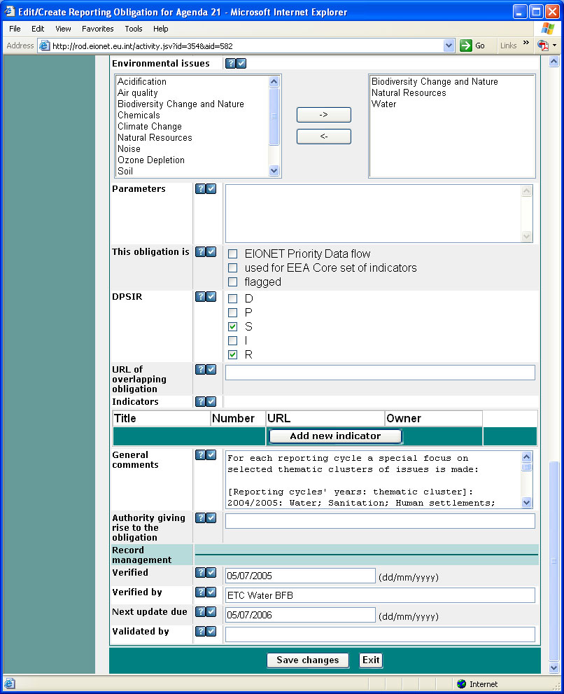Figure 16:Obligation editor (c)

Undo/Redo
ROD allows users to undo certain actions. These actions are editing and deleting obligations or legislative instruments. Clicking on "Show History" button on obligation/instrument page or "Global History" button on the left-hand pane will display a list of previous actions (Figure 17). The window shown on Figure 18 opens, where each action has time, type of object (obligation/instrument), operation (UPDATE, DELETE, UNDO) and user who made the action. Clicking on the object type link will display the changes made by that transaction as shown on Figure 19. To undo a certain action check the action you want to undo and click "Undo selected". After undo it is also possible to redo action. Redo puts the object back into state that it was before undo.
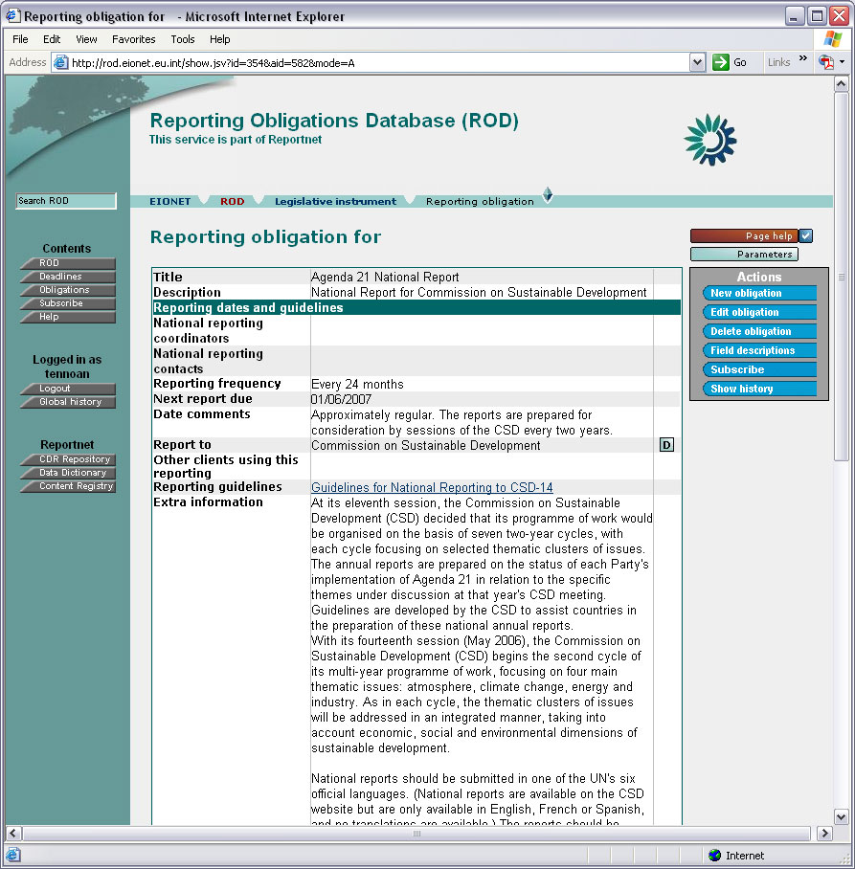Figure 17:Reporting obligation details

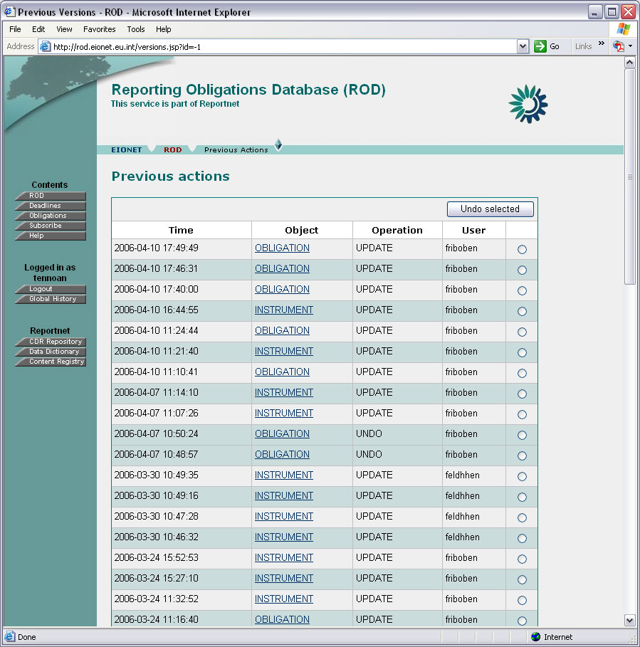Figure 18:List of previous actions
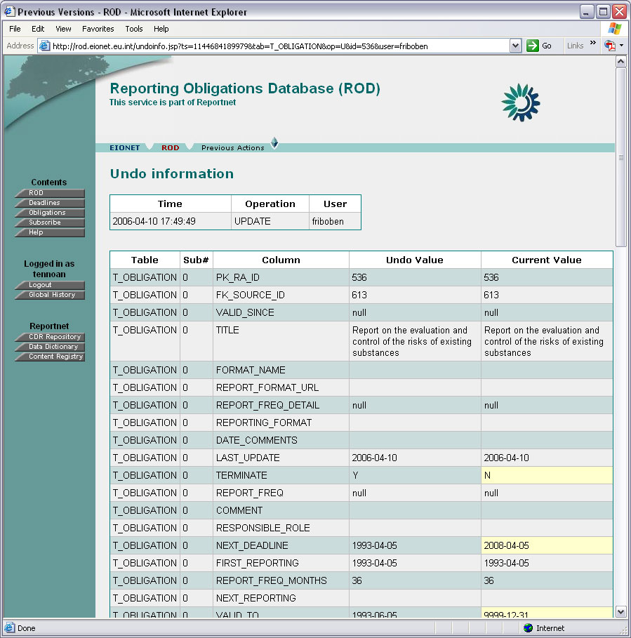Figure 19:Undo information

Deadlines/Deliveries
Deadlines/Deliveries part of ROD, formerly called Country Services, is a tool that helps member countries to co-ordinate and to supervise their international reporting. It does that by gathering and presenting information from various sources (without containing information in itself), helping the user to track the status of ongoing/future reporting processes. In the current version, it gives an overview of the following:
- Which country had/has to report what? [Info from ROD]
- When was/is the deadline? [Info from ROD]
- When is the deadline after the next deadline? [Info from ROD]
- Is the reported data set in Reportnet? [Info from Content Registry]
- Who was responsible for delivering? [Info from CIRCA Directory]
- To who was the data set delivered? [Info from ROD]
Since Deliveries needs a large amount of information from ROD, it is designed as a part of it.
The process starts by selecting ‘Deadlines’ from the left-hand pane of ROD. The window shown on Figure 20 opens.
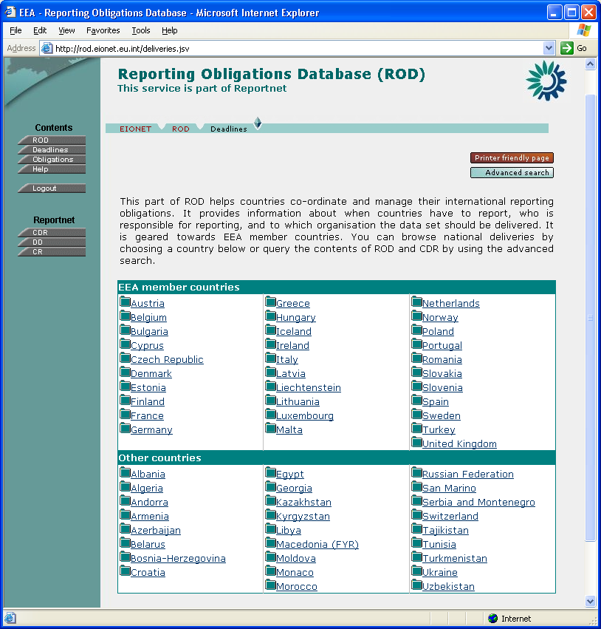Figure 20:The entrance window
From this window, you can either choose a country (the countries are divided to EEA member countries and other countries) to see all status data of (reporting obligation) deliveries for this country, or narrow the amount of data by choosing the advanced search. Choosing a country has the same results as choosing advanced search and specifying that country as the only search criteria.
If the user has the necessary access rights, ‘Harvest’ button also becomes available, allowing the data-gathering process from Content Registry and CIRCA Directory to be run manually. Normally this is not necessary, as ROD is set up to gather data automatically at pre-determined intervals (at least daily).
If advanced search is chosen, the search window shown on Figure 21 opens. From this window, you can narrow the number of reporting deliveries whose status you want to view by specifying country, time period, organization, and/or environmental issue. Clicking on ‘Go’ displays the search results as shown on Figure 22.
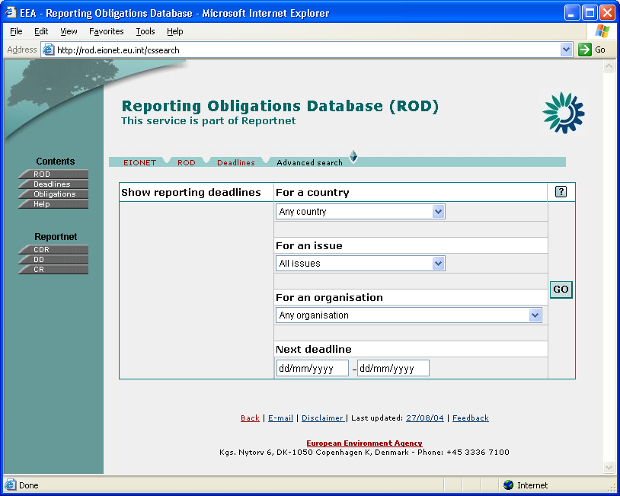Figure 21:The advanced search window
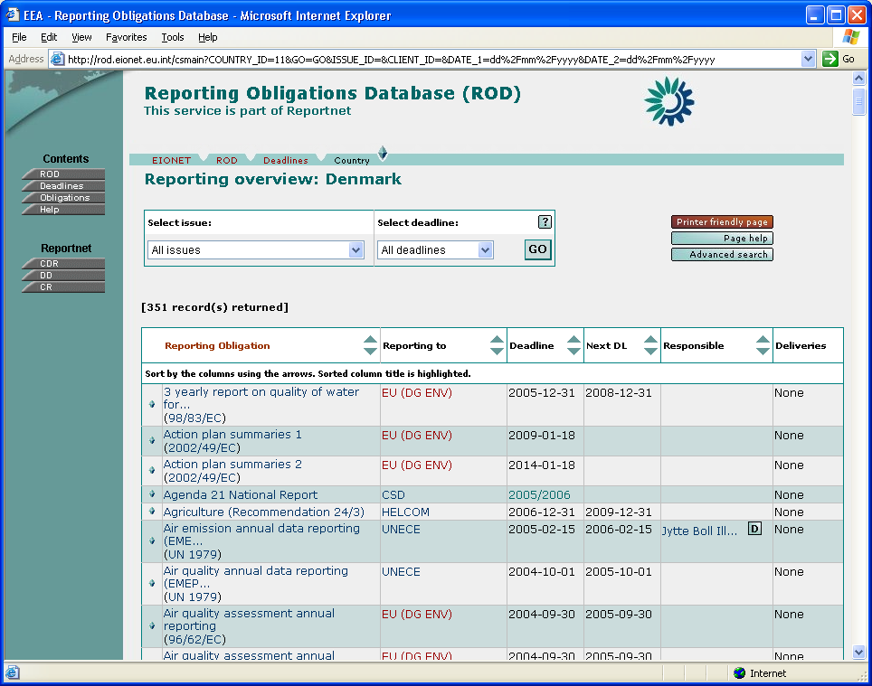Figure 22:Search results
In this window, a list with the following headings is displayed (explained in more detail below):
- Reporting Obligation – link to the reporting obligation related to this delivery.
- Reporting to – the organisation the reported data set needs to be sent to.
- Deadline – The date when the data set is/was due.
- Next DL – The deadline after the above.
- Responsible – the local organisation responsible for carrying out the reporting.
- Deliveries – any deliveries that are in Content Registry for the given obligation.
- Country – only displayed if all countries is used as a search criteria in advanced search.
The entire list can be displayed in printer-friendly format by clicking on the ‘Printer- friendly page’ button. Also, it can be sorted according to column headings by clicking the ascending/descending sort buttons next to the desired column heading. In addition, contents of the list can be quickly filtered (without needing to use the Advanced Search) according to issue and/or deadline by choosing them from the search box at the top of the screen and clicking Go.
Reporting Obligation
This is a link to the reporting obligation in ROD related to this delivery. Clicking on it will display the details of the reporting obligation in ROD as shown in Figure 13. To return to Deliveries, click Back in the browser.
If you browse further in ROD, you can return to Deliveries either by clicking Back repeatedly or by clicking Deliveries button in the left-hand pane.
Reporting to
This is the organisation the reported data set needs to be sent to. For this to be available, the ‘Report to’ organization has to be selected (in ROD) in reporting obligation. In the list, organisation names are displayed. Clicking on the link will open the page with organization details as shown on Figure 23.
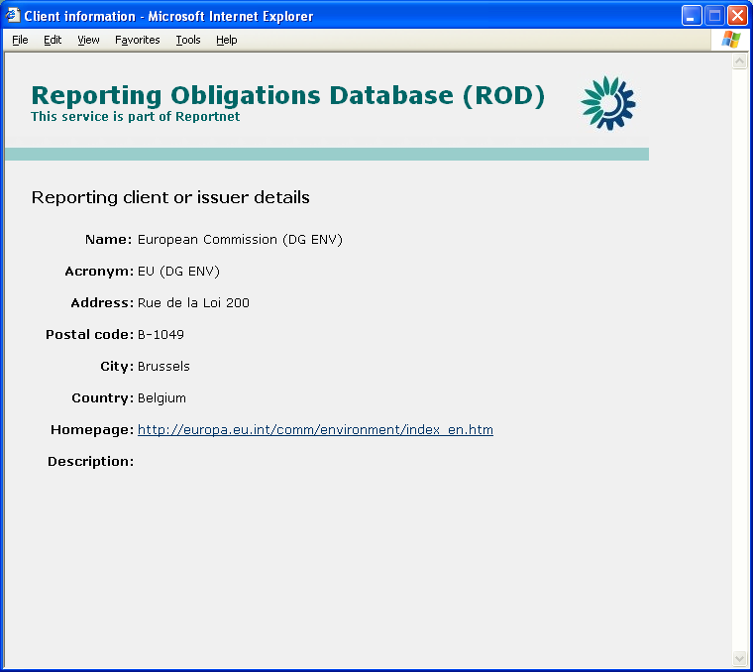Figure 23:Reporting client details
Deadline
This is the date when the data set was due. To correctly display the date, ‘Next due date’ needs to be present in reporting obligation (in date format).
Next DL
The deadline after the above.
Responsible
This is the role responsible for carrying out the reporting. For this to be available, general part of the CIRCA Directory role needs to be available in RA description in ROD. Country Services will automatically add a country code (unless ‘Do not append country suffix’ is selected from Edit Reporting Obligation Details page) to the role and query the Directory. Alternatively, if simply name and URL were entered to Edit Reporting Obligation Details page, the system will display the name here (and link to URL).
In the list, person names are displayed. Clicking on the link will open the relevant page in EIONET Directory, displaying public information. More details are available by clicking on the little ‘D’ button next to the link, but this requires logging in to CIRCA. After entering her CIRCA password, the user can see more information for the role (the password only needs to be entered once during every use of ROD) as shown on Figure 24.
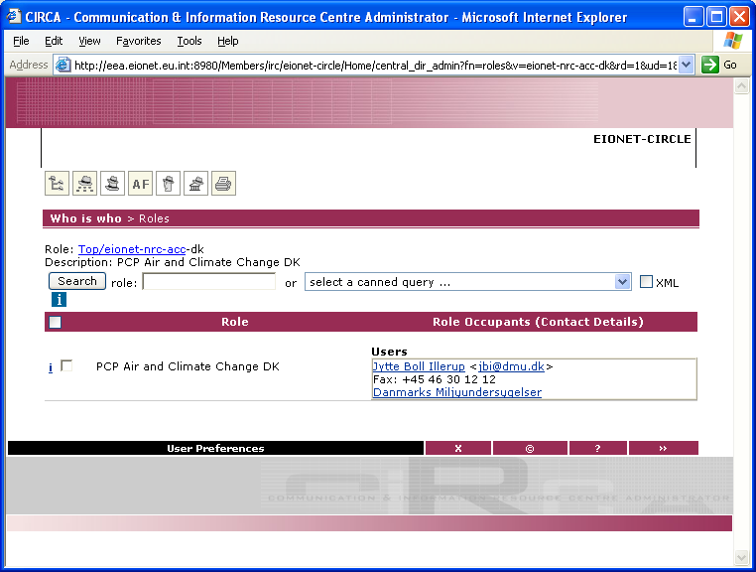Figure 24:Responsible persons for the given organisation (role)
Deliveries
If any deliveries are in Content Registry for the given reporting obligation, they can be viewed by clicking Show List. This will display a window similar to the one shown on Figure 25. Note that in order for the link between Content Registry and Country Services to work, the metadata for the delivery in Content Registry needs to contain global RA ID and country code.
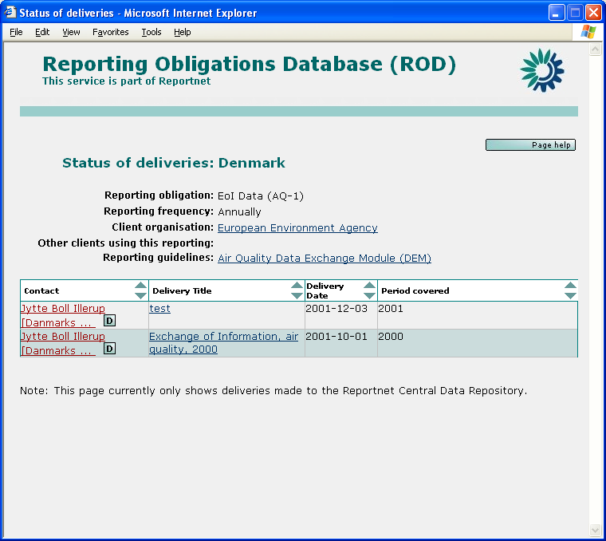Figure 25:List of deliveries for the given reporting obligation
In the deliveries window, in addition to general information, the following fields are available for each delivery:
- Contact
- Delivery (envelope or document) title (clicking on it will open the envelope/document).
- Date the delivery was created.
- Period covered by the delivery.
Note 1: ROD does not know or care about the format of the delivery; it gets it from Content Registry. Most of the deliveries are probably envelopes. ROD will then link to the envelope; it has no way of knowing what the contents of the envelope are because there is no such information in Content Registry.
Note 2: Since there is no sure way to associate deliveries with given deadline, all deliveries are shown for each obligation, regardless of the deadline displayed in the main window. The date when each of the deliveries was added to Content Registry can then be compared with the deadline displayed in the main window to find the desired delivery. ‘Period covered’ field helps with this.
Country
This is only displayed if 'All countries' is used as search criteria in advanced search and marks a country given row applies to.

RSS / RDF
The contents of ROD can be used in several different ways. Currently the main way is to browse the website. The contents of the database are also available for use as RSS, RDF and via XML-RPC. For details, see http://rod.eionet.eu.int/text.jsv?mode=R
RSS (version 1.0):
- Reporting Obligation deadlines: available at: http://rod.eionet.eu.int/events.rss; lists all reporting obligations with their deadline. Only obligations with a numeric date deadline are listed. This feed is used for the Eionet calendar.
- Reporting Obligations: available at: http://rod.eionet.eu.int/obligations.rss; lists all obligations linked to environmental issues specified in the URL.
Note: Use http://rod.eionet.eu.int/obligations.rss?issues=[issueId1],[issueId2], etc. Example: http://rod.eionet.eu.int/obligations.rss?issues=8,9. The issue IDs are: 1 - Climate Change, 2 - Ozone Depletion, 3 - Acidification, 4 - Soil, 6 - Air quality, 7 - Noise, 8 - Natural Resources, 10 - Chemicals, 12 - Various other issues, 13 - Waste, 14 - Biodiversity Change and Nature, 15 - Water.
- Legislative Instruments: available at: http://rod.eionet.eu.int/instruments.rss; lists all legislative instruments.
RDF:
- Reporting Obligations: available at: http://rod.eionet.eu.int/obligations; lists all reporting obligations with linked countries and environmental issues.
- Legislative Instruments: available at: http://rod.eionet.eu.int/instruments; lists all legislative Instruments.
- Countries: available at http://rod.eionet.eu.int/countries; lists all countries.

XML-RPC Methods
Information of ROD can be retrieved by using XML-RPC The XML-RCP router URL is http://rod.eionet.eu.int/rpcrouter and the Service is called WebRODService

At the moment there are five methods available:
getActivities() – returns an ARRAY of STRUCTs, returns all the obligations in an ARRAY, each obligation information put into a STRUCT
Example of an obligation:
{
'COMMENT': 'Resolution 1.8 instructs the Second Meeting of the Parties to review the national reporting format in the light of experience gained from the submission of the first national reports and, if necessary, recommend changes to the format.',
'terminated': '0',
'NEXT_DEADLINE': '', '
SOURCE_TITLE': 'ACCOBAMS',
'DESCRIPTION': 'Triennial National Report',
'details_url': 'http://rod.eionet.eu.int/show.jsv?id=233&#038;aid=556&#038;mode=A',
'TITLE': 'Triennial National Report',
'REPORT_FORMAT_URL': 'http://www.accobams.mc/Accob/Wacco.nsf/Fram5Gb!OpenFrameSet',
'REPORTING_FORMAT': "Resolution 1.8 provides a format for the triennial national report. To avoid redundancy and repetition in successive reports, it is suggested that a format be adopted for the first report submitted by each Party and a more succinct format be used for subsequent reports. Moreover, a slightly different format is suggested for reports to be submitted by Parties that do not border on the area of the Agreement.\n\nThe format will be amended at the end of each Meeting of the Parties in order to take into account Resolutions adopted by the Meeting of the Parties. \n\nThe report is to be submitted in English or French, in triplicate, and accompanied by an electronic version on floppy disk or CD-Rom.\n\nIt is recommended that Parties consult, as appropriate, with relevant non-governmental organisations and others with technical expertise in the preparation of national reports.\n\nThe electronic version of each report received will be available on the Agreement's website.",
'uri': 'http://213.35.204.178:81/webrod/public/obligations/233',
'FORMAT_NAME': 'Format for national reports of the Parties to the Agreement on the Conservation of Cetaceans of the',
'LAST_UPDATE': '2004-01-30',
'PK_RA_ID': '233',
'VALID_SINCE': '2002-03-02',
'NEXT_DEADLINE2': '',
'PK_SOURCE_ID': '556',
'RESPONSIBLE_ROLE': ''
}

getROComplete() – returns an ARRAY of STRUCTs, returns all the obligations in an ARRAY, each obligation information put into a STRUCT All the filed of the obligations are returned
Example of an obligation STRUCT in the ARRAY
{
'REPORT_FREQ': 'annually',
'PK_RA_ID': '8',
'TITLE': 'Yearly report to the Basel Convention',
'TERMINATE': 'N',
'OVERLAP_URL': '',
'REPORT_FREQ_MONTHS': '12',
'FIRST_REPORTING': '1995-12-31',
'NATIONAL_CONTACT': '',
'AUTHORITY': '',
'FK_CLIENT_ID': '6',
'NATIONAL_CONTACT_URL': '',
'FLAGGED': '0',
'VALIDATED_BY': '',
'COMMENT': ": The Convention's secretariat provides the parties to the Convention with prefilled questionnaires. The main request for reporting concerns the amount of different generated wastes and the export and import of them to and from other countries.\nEU Member States have analogous reporting obligation to the European Commission (Waste Shipments Regulation Reporting Obligation from Council Regulation (EEC) no 259/93 of 1 February 1993 on the supervision and control of shipments of waste within, into and out of the European Community) according to Commission Decision 1999/412 /EC of 3 June 1999 concerning a questionnaire for the reporting obligation of Member States pursuant to Article 41(2) of Council Regulation (EEC) No 259/93 (Waste shipments directive).",
'PARAMETERS': '',
'COORDINATOR': '',
'FK_SOURCE_ID': '142',
'COORDINATOR_ROLE': '',
'FORMAT_NAME': 'Transmission of Information questionnaire',
'RM_NEXT_UPDATE': '2004-03-31',
'LEGAL_MORAL': 'L',
'EEA_CORE': '0',
'RM_VERIFIED_BY': 'ETC WMF',
'RM_VERIFIED': '2003-04-25',
'FK_DELIVERY_COUNTRY_IDS': ',28,',
'COORDINATOR_URL': '',
'NEXT_REPORTING': '',
'LAST_HARVESTED': '2004-04-16 10:14:02',
'RESPONSIBLE_ROLE_SUF': '1',
'REPORT_FORMAT_URL':'http://www.basel.int/meetings/sbc/workdoc/manual.html#Transmission',
'VALID_TO': '9999-12-31',
'VALID_SINCE': '',
'LOCATION_PTR': '',
'DATE_COMMENTS': '',
'NEXT_DEADLINE': '2004-12-31',
'DESCRIPTION': 'UNEP Waste Reporting Obligation',
'RESPONSIBLE_ROLE': '',
'REPORT_FREQ_DETAIL': '31 December',
'REPORTING_FORMAT': 'Questionnaire "Transmission of Information" (in accordance with Articles 13 & 16 of the Basel Convention). MS Word text document and MS Excel document (altogether 9 tables).\nManual for the Implementation of the Basel Convention, 10. Transmission of information',
'COORDINATOR_ROLE_SUF': '1',
'LAST_UPDATE': '2003-04-25',
'LOCATION_INFO': '',
'EEA_PRIMARY': '0',
'NEXT_DEADLINE2': '2005-12-31'
}

getROSummary() – returns an ARRAY of STRUCTs, returns all the obligations in an ARRAY, each obligation information put into a STRUCT The STRUCT contains link to obligation , title, last update and description
{
'TITLE': 'Yearly report to the Basel Convention',
'details_url': 'http://rod.eionet.eu.int/show.jsv?id=8&aid=142&mode=A',
'DESCRIPTION': 'UNEP Waste Reporting Obligation', 'LAST_UPDATE': '2003-04-25'
}
getRODeadlines() – returns an ARRAY of STRUCTs, returns all the obligations in an ARRAY, each obligation information put into a STRUCT The STRUCT contains the reporting client name and the next deadline. An example of an obligation data in the STRUCT:

{
'CLIENT_NAME': 'Basel Convention',
'NEXT_DEADLINE': '2004-12-31',
'DATE_COMMENTS': '',
'NEXT_DEADLINE2': '2005-12-31',
'TITLE': 'Yearly report to the Basel Convention'
}

getCountries() - returns an ARRAY of STRUCTs that contains all countries from T_SPATIAL table; each STRUCT has got three country attributes:

- 'ISO' - the two-letter ISO code in capitals;
- 'URL' - 'http://rod.eionet.eu.int/spatial/' [T_SPATIAL.PK_SPATIAL_ID];
- 'NAME'=[T_SPATIAL.SPATIAL_NAME].

Editing other information in ROD
For editing any other information in the ROD (for example the contents in the pick lists) standard SQL queries have to be used. This can be done by data administrators who have direct link to the MySQL database. See also Appendix F.

Actually, the ‘Next due date’ field will update after a given deadline is exceeded by more than ‘Reporting frequency in months’ * 3 days, to allow for some late reporting.

